A Case Study on China’s Sharing Bike Market

Andong Yan

5/5/2017

1. Introduction

During the year 2016, sharing bike business, represented by *OFO* and *Mobike*, rises as the superstar in the China’s capital market, attracting more than a billion yuan during several months. The yellow and orange bicycles, belong to *OFO* and *Mobike* respectively, become to prevail on the streets in China’s big cities. While compared to sharing bike, a business-to-consumer (B2C) time-sharing bike lease is a better description to the business currently operated, I refer them to sharing bike in this paper to avoid confusing. In this paper, I develop a model similar to Bertrand competition model with some modification to capture the customers’ search cost before they start a ride on the sharing bike. With this modified Bertrand competition model, I have some interesting findings: first, competition in this model causes a useless over-production by firms and there seems like to be no equilibrium within the symmetry market context; second, the negative affect of competition tends to shrink in an asymmetry context where products from different firms have different production cost and search cost functions.

The following paper is organized into six sections. Section II introduces the background of China’s sharing bike market and reviews previous literature about the similar price competition contexts. Section III develops the modified Bertrand price competition model. Section IV analyzes the economic model and Section V provides some policy implications based on the economic analysis. Section VI concludes the paper.

1. Background

|  |  |  |  |  |
| --- | --- | --- | --- | --- |
|  | OFO | | Mobike | |
| Deposit (¥) | 99 | | 299 | |
| Price  (¥/hr) | faculty/student | 0.5 | Mobike | 2 |
| non-faculty/student | 1 | Lite | 1 |
| Cost  (¥) | 200-300 | | 3000-6000 | |

Source: https://www.huxiu.com/article/188682.html

Sharing bike business is designed to fulfill the demand of “last-mile” in public transportation. The term “last mile” describes the movement of people and goods from a transportation hub to a final destination. Data (tech qq) shows that sharing bikes are mostly used in the movement from metro and bus stations to users’ destinations, around 63% of total travel scenes, which proves that sharing bikes starts to play a bigger role in daily commute and improves the efficiency of public transportation.

*OFO* and *Mobike* are the two main firms in the sharing bike market. While they both produce bikes themselves and lease them to consumers instead of “sharing” bikes among users, their products and strategies are not the same. Table above shows several major differences between *OFO* and *Mobike*. *OFO* focuses on the campus market during its startup so its pricing is low and even lower to users inside the campus. A companying strategy of *OFO* is building their bikes in a very basic and simple design so the production cost is low enough to remain profitability with the low charging price. In contrast, *Mobike* aims to provide convenient and comfortable experiences of riding on a sharing bike, thus their bikes are equipped with more modules to improve users’ experiences. For sure their production cost is higher as well as their charging price. Another main difference between *Mobike* and *OFO* is that *Mobike* assign GPS modules on their bikes so the user can have the location of bikes on their mobile app, while *OFO* lack such a function for the user to find the bikes easily.

There are growth complaints about both sharing bike firms: first, users reflect that it is really hard to find a bike nearby when they need it, which problem happens to *OFO* more frequently; second, due to factors like easiness of breaking the sharing bikes’ locks, fragileness because of the low-cost structure of the bikes and firms’ lack of management on the prevailing bikes, an innegligible negative externality effect of sharing bikes is overserved. In the following sections, I develop the model with consideration of these factors so people could see the reasoning behind these firms’ business behaviors. Much previous literature has discussed similar economic questions. Hotelling (1929) discovered how would firms react to competition by choosing the location to maximize their market shares. Anderson and Renault (1999) develops a Bertrand-Chamberlin-Diamond model and shows that when there are product diversity and search costs in identifying each firm’s product, market failure could happen. Caplin and Nalebuff (1991) investigate imperfect competition for products with multi-dimensional attributes and find the uniqueness of an equilibrium. In this paper, I adopt the approach from these papers and try to capture what factors and under what condition will market failure occur in the context of China’s sharing bike market.

1. Economic Model

In this section, I develop a modified Bertrand price competition model to identify the behavior of consumers and mobile bike suppliers and see what decisions these parties make under free-market competition. First, it is necessary to introduce the timing of all parties’ actions. At first stage, firms decide their quantity of production $q$ and charging price $p.$ Although the realized level of sales is determined by plugging $p$ into demand curve to have the equilibrium quantity, quantity of production $q$ is determined by firms because there could be an externality of bike’s amount on consumer’s search cost. At second stage, after observing all firms’ decisions on $p$ and $q$ and their own search costs, consumers decide which sharing bike they would like to pay for a ride.

Next, let me describe the market structure. Assuming there are only two firms in the market (this assumption can be easily generalized to a larger number of firms), for example, *OFO* and *Mobike*, and they are competing in providing sharing bike services to *N* customers, who have a demand for public transportation. Now, customers face with three choices, namely, sharing bike service from *OFO*, *Mobike* and an outside option, which can be bus, metro, even walking and any other means of public transportation. Each individual customer, $i∈\left[1,N\right],$ has the following net utility function:

$$u_{j}-p_{j}-s_{i}\left(q_{j}\right), i∈\left[1,N\right], j∈\{1,2\}$$

In the equation, $u_{j}$ denotes the utility of riding sharing bike of firm $j$ and is constant among all customers, $p_{j}$ denotes the price per ride charged by firm $j$, and $s_{i}\left(q_{j}\right)$ represents the search cost for each individual $i$ to search for a sharing bike of firm $j$. Specifically, $s_{i}\left(q_{j}\right)$, is varying with individual because each individual could endure differentiated difficulty to find a sharing bike due to geographical factors, and $s_{i}\left(q_{j}\right)$ is concave and decreasing as $q_{j}$ increases because it is easier to search for a bike if the number of distributed bikes increases. Thus, the “consumer problem” is:

$${Max \{ u}_{1}-p_{1}-s_{i}\left(q_{1}\right), { u}_{2}-p_{2}-s_{i}\left(q_{2}\right),{ π}_{i}\}$$

where $π_{i}$ is the utility from the outside option faced by each consumer. It needs to mention that a general form of demand on sharing bike, $q_{j}=D\left(p_{j}\right)$ also could be derived from aggregating the consumer’s utility function through all consumer’s preference profiles.

Based on the model of consumer’s decisions, we can write down the revenue of the firms, that is:

$${Revenue}_{j}=\sum_{i | u_{j}-p_{j}-s_{i}\left(q_{j}\right)>max⁡\{u_{-j}-p_{-j}-s_{i}\left(q_{-j}\right), { π}_{i}\}}{p_{i}}$$

For better understanding of how market factors affect the revenue of the firms, we assume that the consumer surplus of one ride is higher or equal to the outside options, that is ${ u}_{j}-p_{j}-s_{i}\left(q_{j}\right)≥{ π}_{i}$ and consumers should always choose one of the sharing ride. Besides, we assume $s_{i}\left(∙\right)$ follows some specific distribution $F(∙)$ so that we can estimate the value of $s_{i}\left(q_{j}\right)$ in the aggregate level. Thus, we can rewrite the revenue as:

$$E({Revenue}_{j})=Nθ_{j}{\left(p_{j}{, p}_{-j},q_{j},q_{-j}\right)p}_{j}$$

$$where {θ_{j}(p}_{j}{, p}_{-j},q_{j},q_{-j})=Prob.( u_{j}-p_{j}-s_{i}\left(q_{j}\right)>u_{-j}-p_{-j}-s_{i}\left(q_{-j}\right))$$

With this revenue equation, “firms’ problem” could be written as following:

$${Max}_{p_{j},q_{j}} Nθ_{j}{\left(p_{j}{, p}_{-j},q_{j},q_{-j}\right)p}_{j}-C_{j}(q_{j})$$

The first order condition (assuming second order condition satisfied) is:

$$F.O.C on p_{j}: N(θ_{j}{\left(p_{j}{, p}_{-j},q_{j},q_{-j}\right)+\frac{∂{θ_{j}(p}_{j}{, p}_{-j},q_{j},q_{-j})}{∂p_{j}}p}_{j})=0$$

$$F.O.C on q_{j}: N{\frac{∂{θ_{j}(p}_{j}{, p}_{-j},q_{j},q_{-j})}{∂q_{j}}p}_{j}-\frac{∂C_{j}(q_{j})}{∂q_{j}}=0$$

The first equation indicates that firms are equalizing their marginal gain in revenue of lowering a unit in price ( $\frac{∂θ}{∂p}<0,$ so the sign is correct) to their probability of winning a customer.[1] This suggests that firms should stop lowering the price when the profit from more customers caused by such a price cut cannot cover the loss in price cut. The second equation indicates that firms should stop producing more bikes when their marginal gain in revenue of producing one more unit equals its marginal cost of production, which is according to conventional economic theory.

1. Economic Analysis

Given symmetry production function and search cost of two firms’ sharing bikes, the model should result in similar outcomes as Bertrand competition does, where firms charging a price equal to marginal cost of production. Moreover, films should compensate customers the searching cost they implement by further producing bikes above the demand quantity because a slight cut in customer’s search cost could bring the firm all the market share. However, as both firms raise their production quantities to the same level, the benefits from cutting search cost disappear and firms get worse off since they are still equally splitting the market but their production cost increases. Then a better strategy is to exit the market or decrease the production to a small level that could control the loss in operation. However, given one firm’s chickening out, another firm should also decrease the production level to the demand quantity and the settings turn back to the original point. This suggests that there could be no equilibrium lying in such a competition and firms tend to both end up with the loss. Maybe the worse fact is that there lack great consumer surplus gains from the competition between two firms as the quantity consumed by customers is not affected by the quantity that firms produce and search cost reduction is likely to be small relative to the production cost of an extra bike.

However, the symmetry assumption is not held in all situation. In the real word case, *OFO* and *Mobike* have differentiated products and thus different production cost. *Mobike* builds its products in a reliable and consistent design with higher cost, while *OFO* produces common standard bikes which are low-costing but less reliable. What’s more, *Mobike* assigns GPS module on its bikes while *OFO* does not so the search cost for customers regarding to two firms’ bikes is different. The diversity in production cost and search cost of two differentiated products makes the equilibrium outcome of the competition game different from in the symmetry setting. Intuitively, it is less costly for *OFO* to produce more bikes to compensate customers’ search cost while it is not necessarily for *Mobike* to do so as its search cost function $s_{i}\left(∙\right)$ is relatively small due to equipment of GPS. Therefore, in the resulting equilibrium[2], *OFO* should produce more than *Mobike* while *Mobike* could invest into reduction of customer’s search cost function before the first stage of the whole game to make customers indifferent between two firms and divide the market share.

1. Policy Implication

From the analysis that I conduct in the previous section, and additionally, considering the negative externality of excessive and unorganized sharing bikes, I state several policy implications in this section.

First, it is increasingly obvious that sharing bikes that are scrapped after several uses or parked in the middle of sidewalk by people lacking responsibility are causing inconvenience and problems in city governance. Sharing bike firms like *OFO* and *Mobike* typically do not take care of the scraps that they created, and the burden of scavenging and recycling the discarded bikes is most likely to be on the government. However, according to the analysis of the economic model, the competition between firms could cause an increase in the number of bikes they produce which worsens the negative externality effect that sharing bikes bring to the city. A potential policy to regulate such externality caused by over-production is to impose an environmental tax on each bike that has no GPS equipment. There are two reasoning behind: first, with GPS, it is much easier to locate the bikes and collect them when they are discarded; second, such policy increases the production cost of firms like *OFO* so it enforces these firms to invest in GPS to, not only escape the tax but also compete with other firms in the market of sharing bikes by reducing customers’ search cost. Government policy such as the environmental tax I mentioned above works more efficiently than regulations of enforcing firm to recycle bikes in the sense that it increases competition in sharing bike market as products become more substitutable and firms’ strategies similarity increases. Therefore, a government intervention in the sharing bike market is preferable to increase social total benefits.

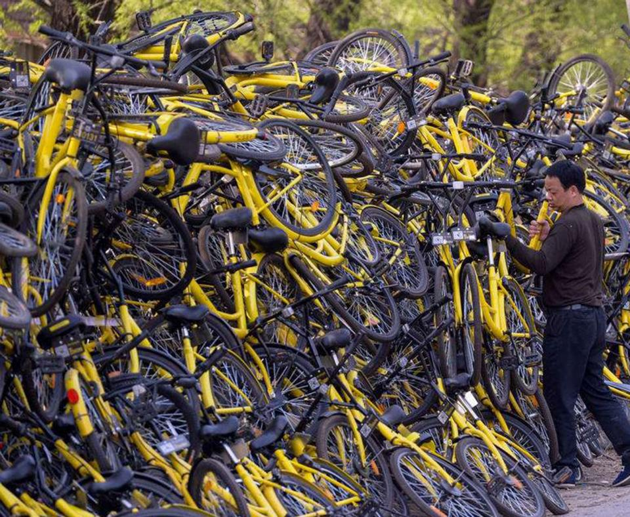

Photo shows a “pile” of OFO bikes without management and occupying local space.

Another policy implication focuses on a large probability event, a merger between *OFO* and *Mobike* in the future. A characteristic of China’s high technology and internet economy business is that mergers between the leading companies in a single market are very likely to happen. Examples contain famous mergers such as Uber and DiDi in the ride-sharing market, Youku and Tudou in the online video market, Meituan and Dianping in local life information market, etc. A reason behind this phenomenon is that these new rising businesses are driven intensively by capital and investors are most unwilling to see two leading firms competing with each other fiercely and suffering a huge loss. Thus, investors usually facilitate a merger between the leading firms to maximize their return of capital. In the case of sharing bike market, the situation remains the same.

However, from the scope of total social benefits, merger between *OFO* and *Mobike* is tolerable as far as the competition reduction effect is offset by the waste-production reduction effect. On other words, a merger allows the left firm to produce exactly at the demand quantity as it does not need to compete in search cost reduction. Meanwhile, competition in sharing bike market comes not only from within the market but largely from across markets. There are various means of public transportation that a customer can choose, and rising the price should dry out the market pool in a dramatic rate. The merger between two firms within the sharing bike market can hardly reduce the competition that the combined firm face after that, while the rational level of production could reduce the cost without deteriorating anyone’s benefits. In one word, if a merger between *OFO* and *Mobike* is proposed someday, there is no need to prevent the transaction from happening.

1. Conclusion

In this paper, I develop a modified Bertrand model to identify sharing bike firms’ behavior when customers enjoy a search cost for bikes. I conclude that due to incentives of capturing bigger market share, firms tend to compensate customers’ search cost by over-producing bikes. In a symmetry exists between firms, there could be no equilibrium and the competition between firms results in an operation loss and decreased total social benefit; while in an asymmetry context, firms can differentiate their products and implement different strategies to compensate search cost, namely increasing number of bikes and decreasing search cost by GPS. Further analysis suggests government impose a tax on bikes without GPS to enforce decreased production level as well as more competition. However, due to competition across markets, a merger between firms in sharing bike market has not a significant harm to consumer surplus.

Reference

Anderson, Simon P., and Regis Renault. "Pricing, product diversity, and search costs: A Bertrand-Chamberlin-Diamond model." *The RAND Journal of Economics* (1999): 719-735.

Caplin, Andrew, and Barry Nalebuff. "Aggregation and imperfect competition: On the existence of equilibrium." *Econometrica: Journal of the Econometric Society* (1991): 25-59.

Hotelling, Harold. "Stability in competition." *The Collected Economics Articles of Harold Hotelling*. Springer New York, 1990. 50-63.

1. Due to limit of time, more illustration and explanation could have been explored from this condition but unfortunately not.
2. However, whether such equilibrium exists is not checked due to limit of time.